

{ DOCUMENTATION }

{ TABLE OF CONTENTS }

{ TABLE OF CONTENTS } 2

{ BACKGROUND } 3

{ INITIAL SETUP } 3

Step 1 – Download 4

Step 2 – Selecting Shared Path 5

Step 3 – Registration 6

Step 4 – Schedule Selection 9

{ ACCESS LEVELS } 10

Read-only 10

Privileged 11

Admin 14

{ BUILDING THE SCHEDULE } 15

Schedule Manager – Adding Crew Members 15

Schedule Manager – Adjusting Crew Roster 18

Schedule Manager – Adjusting Starting Hours 20

{ Managing Schedule Data } 21

Schedule Types 21

Appendix A Overtime Schedule 22

Appendix B. Work Schedule & Date Header 23

Entering Schedule Data 24

{ BACKGROUND }

This application provides a user-friendly interface for storing and managing crew schedule data in industrial settings. Developed with the complexities of shift work and overtime management in mind, it offers a robust solution for supervisors and managers to efficiently organize their team's schedules.

Key Features:

1. Dual Schedule Management: Handles both regular work schedules and overtime allocations.
2. User Access Control: Implements a tiered access system (admin, privileged, read-only) to ensure data security and integrity.
3. Intuitive Interface: Offers an easy-to-navigate GUI for quick schedule creation and modification.
4. Data Persistence: Securely stores schedule information for long-term record-keeping and analysis.
5. Automated Calculations: Handles complex overtime calculations and shift pattern generation automatically.
6. Reporting Tools: Includes features for generating printable schedule reports and data exports.

The app comes with deeply considered automations for securely building and managing your crew in a more convenient way without forsaking the need to securely store the data from unauthorized editing. It aims to streamline the scheduling process, reduce errors, and provide a clear overview of workforce allocation.

This tool is particularly useful for industries with complex shift patterns, such as oil and gas, manufacturing, or healthcare, where maintaining accurate schedules is crucial for operational efficiency and compliance with labor regulations.

The Initial Setup guide within this documentation should provide enough information to get the user started. As you explore the application, you'll find that it offers flexibility to adapt to various scheduling needs while maintaining a straightforward user experience.

If there are any issues encountered with this application, you have recommendations for improvement, or if you need more information, please feel free to reach out to the developer at [matthewdunaway@chevron.com](mailto:matthewdunaway@chevron.com)

Your feedback is valuable and will contribute to the ongoing improvement of this scheduling tool.

{ INITIAL SETUP }

Step 1 – Download

Begin by downloading the Plan_Matrix application from company portal.

In the download location, you’ll find two files:

1. The Plan_Matrix Application denoted by the Tree logo



1. A folder named “images” containing various image files used by the application for its cosmetic appearance.

In order for the application to work as expected, these additional files *[images, SaveFiles]* should not be tampered with. The application will not open due to an error if the image files are not located in the same directory as the application. The application shared path will need to be reselected if the SaveFiles folder is removed or moved. If you do not see a SaveFiles folder, then a shared path has not yet been selected. Read on for more on selecting the shared path for the application.

Step 2 – Selecting Shared Path

Open the application and you’ll be prompted to select a ‘shared path’.

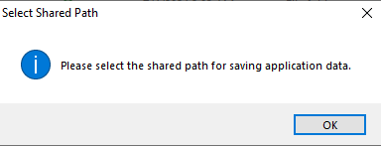

Shared Path refers to a file location accessible to numerous personnel on various internal computer systems.

***Note:***

*It is recommended to select a location in the ‘O: Drive’ (i.e. ‘share Drive’) that is applicable to your unit.*

Regardless of your selection, for a crew of personnel to manage the same schedule data, the shared path will need to be the same. Be sure to communicate the shared path to others in your area to ensure they can view and manage *the schedule appropriately!*

Once you have selected your shared file location, click “Select Folder”.

The shared path will be stored in a new folder in the application directory called “SaveFiles”. Shared path will be located in a text file called ‘shared_path.txt’. Moving or deleting this file will erase the shared path stored and new one will need to be selected to use the schedule.

Step 3 – Registration

On the registration page, the user’s username will be detected and they will select a password.

There are three options on this page.

1. Confirm Login Information – Once a user has successfully entered their new password, the Registration window will disappear, and the login window will appear when this button is clicked.
2. Bypass Login (read-only) – Selecting this button will bypass the registration process affording the user “read-only” access. They will not have any editing options and certain menu buttons will not work in read-only.
3. Close App – Opens a dialog allowing the user to close the application or leave it open.

When the user enters their password and confirms login information, the password will be securely encrypted (256-AES) and filed accordingly in the shared path UserRegistry folder (in SaveFiles).

Upon successful registration, the prompt above will appear and the next window they will see will be the Login page.

On the Login page, the user will enter their selected password and login. There are two differences between this page and the Registration page I’ll outline below:

1. Remember my password – If this box is checked, the password will be stored and remembered each time the user logs in. This will prevent the user from having to login to the app each time it’s opened. If the box is unchecked, the user will have to login with their password each time the application is opened to the login window.
2. Forgot Password? – Selecting this link will open a new window to reset the users password

Step 4 – Schedule Selection

On the schedule selection page, the user will select and confirm the schedule they wish to view (i.e. shown below: A Crew, January, 2024, Overtime Schedule)

* Select Crew – A, B, C, D
* Select Year – Any year from 20 years in the past or future of the current year. Future years greater than 1 year in the future cannot be selected.
* Schedule Type:
  + Overtime Schedule – Used to track personnel overtime throughout the year.
  + Work Schedule – Displays the role/placement of personnel on crew as specified by the schedule manager creating the schedule (i.e. Head Operator on crew)

{ ACCESS LEVELS }

Read-only

On first login, any user without the required “Key” will proceed with read-only access.

In read-only:

* The viewer can view the selected schedule but cannot make changes to the schedule data.
* Saving is not permitted.
* The Buttons on the left-hand navigation pane will not work.
* Menu Bar options are limited. Below are the Menu Bar options that work in read‑only:
  + File:
    - Select Schedule Date – Select a new schedule
    - Schedule Type – swap between “Overtime” and “Work” Schedules
    - Print – Open a PDF view of the current schedule to print
    - Select New Shared Path – Select a new path as completed in initial setup. This is a user-specific feature so it will not affect anyone else if a user selects this.
    - Exit – Closes the Schedule
  + View:
    - View Tracking Log – Opens the tracking log for the selected schedule. Shows changes made since the schedule was created.
  + Help:
    - About – Opens the Documentation associated with the Application (This document)
    - Help – Opens an Outlook (Email) instance to forward communication to the developer. Use for reporting application bugs or recommendations.

Privileged

On first login, any user without the required “Key” will proceed with read-only access. To obtain higher access levels, a secondary application is needed to revise the access level encryption file (The encryption file cannot be read or revised manually for access control).

The secondary application is the Key provided through the application host after obtaining required permissions.



After obtaining the Privileged_Key application, the user will open the application and be prompted to select the shared path.

**IMPORTANT: The user must select the same shared path they have specified with the Plan_Matrix application**

***For example:***

*If my shared path I selected for the Plan_Matrix application was: “O:\Operations\CRACK1\MDGL\Test_Dir”*

*..then the shared path I would select for the Key application would be: “O:\Operations\CRACK1\MDGL\Test_Dir”*

*Because of this, it is recommended to keep the Key in the same folder as the Plan_Matrix Application on your computer. The shared path will automatically be detected and selecting the path will not be necessary.*

Once the correct path is selected, this window will appear:

In the window, you should see your username with the steps to activate. Simply click the button to gain access and you should see:

To assure you have the access, click the button again and you should see:

Once you are assured you have the access, close the key app and open the schedule.

In privileged access:

* The viewer can view and make changes to the schedule data
* Saving is permitted.
* The Buttons on the left-hand navigation pane will work.
* Menu Bar options are unlimited. Below are the Menu Bar options that work in read‑only:
  + File:
    - Select Schedule Date – Select a new schedule
    - Schedule Type – swap between “Overtime” and “Work” Schedules
    - Save – Save the schedule data manually
    - Auto-Save – When enabled, certain triggers will save the schedule automatically (switching between work/overtime schedules, selecting a new schedule, using schedule manager, closing the schedule)
    - Print – Open a PDF view of the current schedule to print
    - Select New Shared Path – Select a new path as completed in initial setup. This is a user-specific feature so it will not affect anyone else if a user selects this.
    - Exit – Closes the Schedule
  + Edit:
    - Open Schedule Manager – Allows the user to adjust the crew members in the crew of the selected schedule. Adjustments are forwarded through from the current selected month to the end of the year. Keep in mind, making changes in an earlier month, will also affect the roster for each month thereafter.
    - Manage Access Levels – Allows the user to revise the access level of personnel to read-only or privileged. Prevents the need for multiple people to need a key per area. Once one person has privileged access, they can then adjust the other management to/from read-only if needed.
  + View:
    - Navigation Pane – When enabled, hides the Navigation Pane (Button Menu). When disabled, it reappears.
    - View Tracking Log – Opens the tracking log for the selected schedule. Shows changes made since the schedule was created.
  + Help:
    - About – Opens the Documentation associated with the Application (This document)
    - Help – Opens an Outlook (Email) instance to forward communication to the developer. Use for reporting application bugs or recommendations.

Admin

Admin Access is solely for developer/application handlers.

The only difference between this Access and Privileged is an additional menu bar tab and the option for “Admin” under Manage Access Levels:

* Edit:
  + Manage Access Levels – Allows the user to revise the access level of personnel to read-only, privileged, or admin.
* Administrator:
  + Log File - View the Program Log for troubleshooting and reference
  + UserID CSV – Opens the SaveFile UserRegistry containing the user list and selections opted by each user for a specific shared path. This will only be used if a manual revision or reference is needed by a developer assisting an area.

{ BUILDING THE SCHEDULE }

Schedule Manager – Adding Crew Members

When first opening this schedule, the user will be met with a notification prompting them to utilize the Schedule Manager to add new crew members. The schedule page will be blank as there are no crew members added.

Note: At this point, the user must have a minimum of Privileged access to proceed further. Schedule Manager requires privileged or admin and is not accessible in read-only access. For more information, please review the { ACCESS LEVELS } chapter of this manual.

Open the Schedule Manager either by selecting from the Menu Bar or by clicking “Open Schedule Manager” from the Navigation Frame button options.

Menu Bar Selections - [**Edit** >> *Open Schedule Manager*]

Opening the schedule manager will open the window shown below:

|  |  |
| --- | --- |
| Click “Add New Name” and the window shown below will appear. Pressing the Tab key or clicking the green “+” button will add new fields for entering multiple names. Pressing Ctrl+z or clicking the red “-“ button will remove added fields if too many are created. |  |

Once all names have been entered, click “Confirm” and the changes will be processed. New names should now be visible on the schedule.

**Note:**

It’s important to note that once names have been added to the schedule, those names will be added to both the Work Schedule and Overtime Schedule.

The added names will populate for the month the user is currently viewing, as well as every month after the month they are viewing. This means that if a user is building the schedule in a month after January, those names will not populate in the months prior to the month they built the schedule in. It is advisable to always build the schedule from January and revise as needed in later months to avoid potentially overwriting data.

Schedule Manager – Adjusting Crew Roster

Schedule Manager is primarily used to adjust the personnel list of a crew schedule. There is one added function that we’ll discuss at a later time.

The begin editing the roster, familiarize yourself with the Name Tree highlighted below. Each name can be highlighted in the roster by clicking the name from the tree.

* Add New Name – Add one or multiple names to the schedule. If there are preexisting names on the schedule, new names will be added to the bottom of the list.
* Remove Selected Name – Removes the highlighted name from the schedule. This will also remove any data for the individual (Hours/Role schedule data) for the month being currently edited as well as months after the month being currently edited.
* Move Up – Moves the selected name up the list. Once a move is made, the shift will reflect in the schedule. This also moves the schedule data associated with the moved name
* Move Down - Moves the selected name down the list. Once a move is made, the shift will reflect in the schedule. This also moves the schedule data associated with the moved name
* Edit Selected Name – When click a name in the tree, the name becomes visible in the field to the right of this button. The name in this field can then be edited. Once the name is edited, clicking this button will apply the name edit without erasing data.

**Note:**

Each time any of these changes are made, the user will see a “Processing Changes” prompt window appear in front of the Schedule Manager window.

|  |  |
| --- | --- |
| The processing window shows the progress of applying the requested changes to the actual schedule. All changes are passed and processed immediately after initializing.  Once the window disappears automatically, the schedule will reflect the change made by the user. |  |

Schedule Manager – Adjusting Starting Hours

The final feature of the schedule manager only applies to the month of January for a given year. You will not see this option in the months that follow.

At the beginning of each year, if schedule data exists for the year before and a new schedule is created, the Overtime hours from the previous year will automatically be ranked in order of lowest to highest:

Lowest: 0 | Highest: x-1 (x = Number of persons on crew. Subtracts 1 since it begins rank at 0)

If the ranking needs to be changed for any reason, whether it be a new crew member or unaccounted hours from the previous year, the starting hours of each name can be adjusted to manually change each person starting asking hours and starting working hours.

To make the adjustment, select the name from the tree, enter the new starting hours in the entry fields, and click “Change Hours” button to apply the new hours.

{ Managing Schedule Data }

Schedule Types

There are two versions of the schedule to be used synonymously in tracking personnel data. Overtime Schedule is used for planning and tracking overtime shift hours for each crew member. Work Schedule is used for planning and tracking scheduled roles for personnel through the month.

To swap between schedule types use the Quick Access Pane (Options shown below)

|  |  |
| --- | --- |
|  | **Quick Access Navigation Pane**  **Select Schedule Menu** – Select a new schedule date and crew  **Open Schedule Manager** – Open the Schedule Manager  **[ Work Schedule ] / [Overtime Schedule ]** – This button swaps between both schedule Types  **Save** – Save the Schedule Data |

In the next few sections, we’ll cover the differences between both schedule types and elaborate a bit on some of the automations.

Appendix A Overtime Schedule

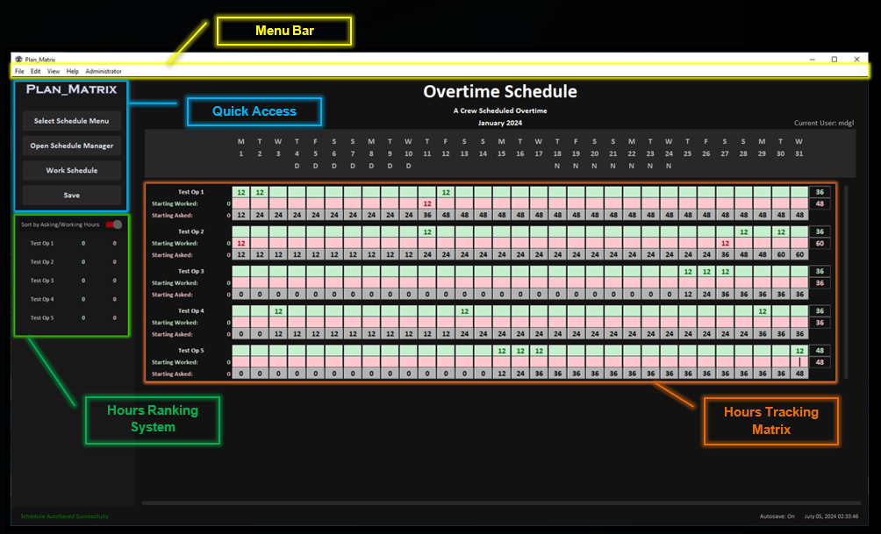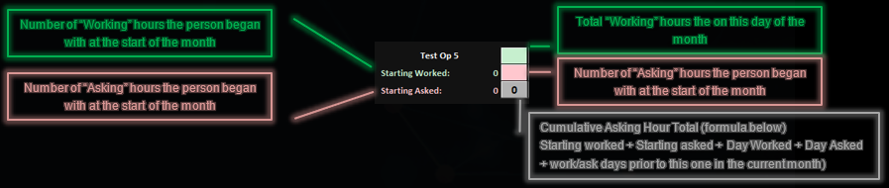

Appendix B. Work Schedule & Date Header

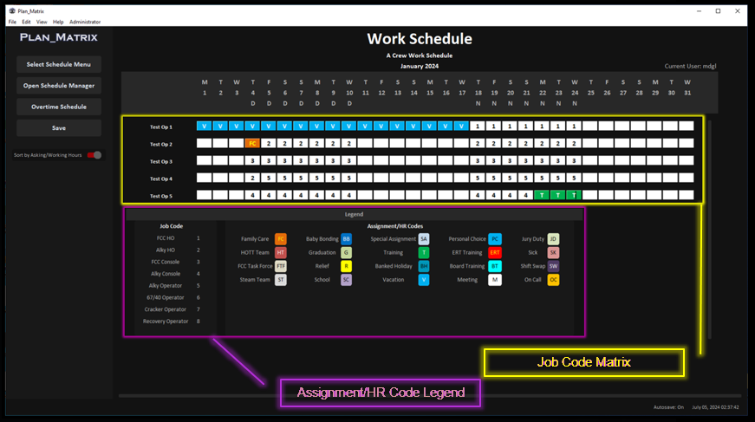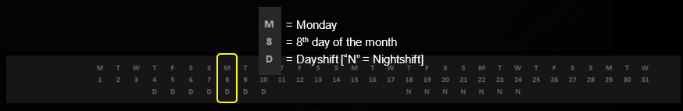

Entering Schedule Data

placeholder